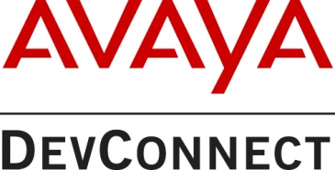

2017 Avaya DevConnect Customer Innovation Award

The Avaya DevConnect Customer Innovation Award recognizes the significant achievement of an Avaya Support-enabled or Registered level Customer member for innovative, customer-driven development of in-house solutions for use with one or more Avaya platforms to attain tangible organizational benefits.
The award is based on the following characteristics of excellence: Leadership, Innovation and Customer Focus.
Winners will be announced on Thursday, 25 May 2017.
Award Guidelines:
Eligibility: Avaya Support-enabled and Registered level customer members in good standing who have completed solutions leveraging Avaya products API’s.

Submission Deadline: Email to devconnect@avaya.com no later than 4th May 2017 and include “Customer Innovation Award Form” in the Subject line.

Questions? Contact DevConnect at devconnect@avaya.com.
Company Information
Company Name: |  | Country:
Submitter Name: | Phone: | Email:
Provide a short description of your company :
Solution Information
Provide a brief overview of your solution :
With which Avaya products does your solution interoperate?
Leadership - Describe how the solution benefits your organization:
Innovation - How is the solution creative, innovative or unique?
Customer Focus – How does the solution help build stronger customer relationships or increase customer satisfaction?

